#### 

## Field Guide

VA.gov CMS: Facility

Veteran Patient Research

|  |
| --- |
|  |

**VA.gov CMS Team**

#### Conducted January 8-10, 2018

#### 

# Schedule

## Arrive in Pittsburgh, January 7

## Research Day 1, January 8

*Day's focus*: **User journey** to VAMC Pittsburgh and their awareness of other benefits on entering and (if possible) exiting

## Research Day 2, January 9

*Day's focus*: **Recreate relevant tasks** using pittsburgh.va.gov / other websites

## Research Day 3, January 10

*Day's focus*: **Card sort to organize information** in pittsburgh.va.gov's existing IA

|  |  |  |
| --- | --- | --- |
| **8:00-8:50 AM** |  | Arrive at Atrium at University Drive (+ Mail lobby at Heinz) |
| **9:00-11:30 AM** |  | Research (see *Conversation Guide*) |
| **11:30-11:50 AM** |  | Break down table, store |
| **12:00-12:50 PM** |  | Lunch calibration & debrief (see *Debrief Guide*) |
| **1:00 - 4:30 PM** |  | Research (see *Conversation Guide*) |
| **4:30-5:00 PM** |  | Break down table, store. Clean up thoroughly. |
| **Optional** |  | Artifact analysis over dinner |

## Depart, January 11

# Research Team

### VAMC Pittsburgh site contact

Shelly Nulph, shelley.nulph@va.gov

### 

### DSVA team

Jeff Barnes

Jennifer Lee

### VA.gov CMS team

**C. M. Kennedy, point of contact for veteran experience, 212-951-1941**

Meghan Casey

Stephanie Lawrence, incentives point person

Kevin Walsh

# 

# Field Research Checklist

### 2 days in advance

* Purchases
  + Incentives: 30 $25 Visa cash cards
  + Supplies: post-it notes, index cards, clip boards, folders, pens, sharpies

### Day before

* Print all documents needed in the field, put them into folders
  + 50 consent, 8 field, 15 defrief guides, 75 recruit flyers (cut into 2=150)
* Lay out all items for your research kit, such as:
  + Camera, microphone, laptop, smart phone
  + Extension cord, power strip
  + Printouts, incentives, backup physical cards for card sort
  + Clipboards, post-it notes, sharpies, ball-point pens, blank index cards, folders

### Night before

* Aim to get a full night's rest
* Plug in all electronic devices to make sure they are fully charged on research day
* Fill water bottle and put it near your research kit

### Day of

* Plan to leave with double the time you estimate it will take for you to arrive in a timely fashion to the site
* Make sure all electronic devices not in use are powered off
* Pack up your research kit
* Make sure incentives are in a secure place and with the incentives point person
* When leaving the site, make sure to leave it tidy and to do a second check to make sure you haven't left anything behind
* If more incentives are needed, be sure to purchase before research day 2 or 3
* Incentives point person will track which cards were issued at the end of the day

### Research complete

* Leave the site tidy, as or better than you found it
* Ensure any extra incentives are with the incentives point person so they get tracked and stored in a secure location
* High five!

# Recruit Flyer

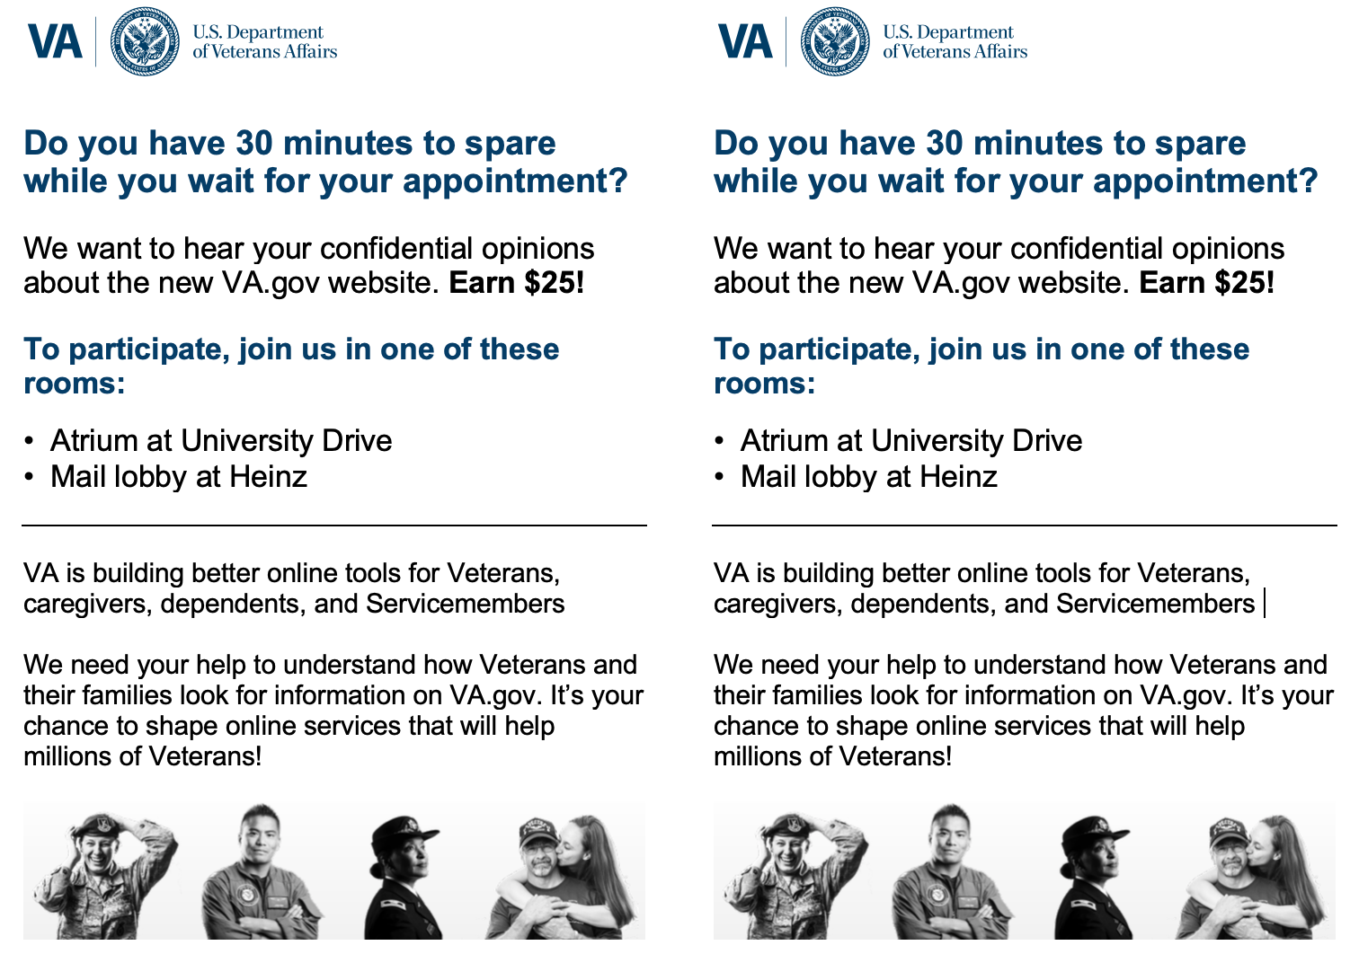

# Consent (~3m)

Thank you for joining us today.

Do you have about **30 minutes** to answer a few questions about a website created by the Department of Veterans Affairs?

Once we complete our time together, we'd like to offer you a $25 Visa cash card to thank you for your time.

## I'm going to start by reviewing a consent form with you.

## 

## Ready?

## 

Researcher: Read the **VA Research Participation Consent** to the participant (see following page)

## VA Research Participation Consent

## 

## Session Description

## You are being asked to participate in a feedback session to give your opinion on a website created by the Department of Veterans Affairs. By participating in this feedback session, you will help the VA improve this website.

## This feedback session will take 20-30 minutes. We'll ask you some questions and show you a website design. We won’t use your name in association with anything you say during the session.

## You may quit the session at any time. If you need a break, just tell the us. If you have questions, go ahead and ask them whenever you like.

## 

## Consent

## By initialing below and signing this form, I give my permission for the VA to use:

## · Written notes of verbal statements (initial here ______)

## 

## I understand that I may quit the session at any time. If I need a break at any time, I will tell the moderator. I agree to ask questions about the session if I don't understand something. If I have questions after the session is over, I can contact the DSVA team at feedback@va.gov.

## I expressly release the Department of Veterans Affairs from and against any and all claims, which I have or may have for invasion of privacy, defamation, or any other cause of action arising out of the production, distribution, display or publication of the results of the project, as the conditions described above are met.

## 

## By signing below, I indicate agreement with these terms above.

## Name (printed) ___________________________________

## Signature ___________________________________

## Date ___________________________________

## 

# Conversation Guide

Researcher: ensure HIPPA/privacy compliance throughout the interview.

### About the study (~1m)

* As I speak to you today, I may sound like I’m asking “why” a lot. That’s because I want to make sure I capture your details correctly.
* I did not design anything you're going to look at today, I’m just collecting feedback.
* As we talk today, please be honest with your positive and negative thoughts.
* Nothing you say about what we look at today will hurt my feelings.
* Before I ask you a few background questions, I want to remind you that your job is just have to be yourself and act as you naturally would.
* I will now begin recording the session [Researcher: Make sure to begin recording!]

### Background Questions

* When did you serve and which branch? *Thank you for your service*.
* Is this your local medical center?
  + Have you been to any other veteran medical centers?
  + If yes, how does this one compare?
* [as needed for Day 1] Did you use any website for your visit today?
  + If yes, can you explain how you used a website?
  + If no, did you make the appointment or prepare for the visit today? If so, how?
* Are you involved in any groups with other veterans?
  + If yes, which and why?
  + If no, why?
* *Thank you for answering those questions.*

## 

## Interview questions

## Day 1: User journey to VAMC Pittsburgh and their awareness of other benefits on entering and (if possible) exiting

### Intro

1. We 100% respect your privacy, so if you're here for an appointment, please do not feel like you need to tell us why. You can refer to it as "the appointment" or "my appointment". We'd like to ask that you don't divulge your personal medical information during the interview.
2. Are you involved in any groups with other veterans?
   1. If yes, which and why?
   2. If no, why?

### Background Questions

1. Is this your local medical center?
   1. Have you been to any other veteran medical centers?
   2. If yes, how does this one compare?
2. How did you learn about the Pittsburgh VA medical center?
3. Let's walk through your story of how you prepared for today. How did you plan for your visit today?
   1. When did you begin planning your visit today?
   2. Is there anything that you needed to do to prepare for today? Like any forms, medical tests, or records?
   3. Did you use any website for your visit today?
      1. If yes, can you explain how you used a website?
      2. If no, did you make the appointment or prepare for the visit today? If so, how?
4. Did you have to look up any contact information for today?
5. Do you think there could have been anything that would have made your life easier for preparing today’s visit?

### Journey-focused (Thursday only)

1. How did you get here today?
2. Did you come by yourself?
3. Did you have any issues with today’s visit?

### Wrap-up

1. How did you learn about your available benefits?
   1. How you look up or research: online, word of mouth, or any other ways.
      1. If you you did look up, which websites [capture those websites]
   2. How did you sign up for them?
      1. Do/have you apply(ied) for VA benefits or services online before?
2. During the screener, you entered the VA benefits that you currently use. However, what types of benefits do you **wish** the VA would offer, that they currently don’t?
   1. How would you go about finding out whether those wished-for [use the words the participant used earlier] benefits are offered?
   2. [Researcher: don't share until after the visit]. Did you learn of any new benefits during this visit?

### Exit

1. May I text or email you with follow-up questions, or if we'd like to speak with you further in another interview? If yes, may I get your mobile number? If no: understood, thank you.
2. *Thank you for answering those questions.*

## Day 2: Card sort to organize + prioritize information contained in p.va.gov's existing IA

### Background Questions

* When did you serve and which branch? *Thank you for your service*.
* Is this your local medical center?
  + Have you been to any other veteran medical centers?
  + If yes, how does this one compare?
* [as needed for Day 1] Did you use any website for your visit today?
  + If yes, can you explain how you used a website?
  + If no, did you make the appointment or prepare for the visit today? If so, how?
* Are you involved in any groups with other veterans?
  + If yes, which and why?
  + If no, why?
* *Thank you for answering those questions.*

Researcher:

* Make sure Optimal Sort or your card stack is ready for the ***organization sort****.*
* Explain the task: This is kind of a card game.
  + Each card in this stack has the name of something that you might see on the website. I’d like you to organize the cards into groups that make sense to you.
  + You'll have about 10 minutes, so take your time!
  + There are no right or wrong groupings. Try to organize all the cards, but not everything needs to belong in a group.
  + You won’t have to provide a reason why cards belong in the same group, so if a group feels right, go with it.
  + Focus on what makes sense to you, not what may make sense to anyone else.
* Timebox this activity to about 10 minutes
* Can you tell me why you made each of these groups?
* Which card is the best example of each group?
* Which groups were easiest to assemble? Which were hardest? Why?

Researcher:

* Make sure Optimal Sort or your card stack is ready for the ***prioritization sort***.
* Explain the task:
  + Now, can you organize the cards without thinking too much into one of these categories
    - 0 – Not valuable information
    - 1 – I wouldn't expect this information to be on the site
    - 2 – I might expect this information to be on the site
    - 3 – I would go to the site specifically for this information
    - You'll have about 5 minutes
  + Timebox this activity to about 5 minutes
  + For items 1 through 3:
    - Where or from whom would you expect to get this information?
    - Could you rank them in terms of how often you need this information?
* Researcher:
  + Time permitting: Now do the tree test. Instructions are in Optimal Workshop.
  + Task 1 through 3: find common information on the site (based on findings from Day 1)
  + Task 4: Pick one unique item from card sort above.

### 

## Day 3: Recreate relevant tasks using pittsburgh.va.gov / other websites

### Background Questions

* Is this your local medical center?
  + Have you been to any other veteran medical centers? wnhjnjjn
  + If yes, how does this one compare?
* [as needed for Day 1] Did you use any website for your visit today?
  + If yes, can you explain how you used a website?
  + If no, did you make the appointment or prepare for the visit today? If so, how?
* *Thank you for answering those questions.*

Researcher: make sure to have [Silverback] screen recording on

* Have you looked up information regarding the VA before? Or topics related to being a veteran (like benefits, Veteran groups, etc.)?
* Have you used the website for the PIttsburgh VA before?
  + If yes: What did you use it for?
  + If no: Why not? [if needed} What would you want to use it for, if you could?
* You mentioned you've looked up/would want to look up [x or y] as part of your visit today. Using this computer, would you recreate those steps for me and think aloud as you go?
* Next, we're going to complete some tasks I'll ask you to complete. First, let's go to the homepage: <https://www.pittsburgh.va.gov/>
  + Can you give me your first impressions of this page? See anything you find confusing? Interesting?
* For these tasks, I'd like you to use this site to complete them. Please think aloud as you do so, and tell me anything you like, dislike, find confusing or interesting. [if needed] If at any point you're frustrated and would otherwise give up and go to another site or try another method, let me know. Please act like you were looking this up yourself at home, without me being here.
  + [Goal for tasks 1-3: find out if the site can inform people about what benefits exist, that myhealthevet exists, and services/events at the VAMC]
  + Task 1: Look for information on what to do for your first appointment here.
  + Task 2: Look up how to set up an appointment here.
  + Task 3: Look up the schedule for a service/event being offered.
  + Task 4: [have the participant pick something themselves. Show the cards from the card sort if needed.]
  + Follow-up questions:
    - What else do you need to know about this topic?
    - Is this what you were expecting to see on this page?
      * Did you find all of the information you expected to see?
    - Did the amount of information feel right to you?
    - At any point did you feel lost? What would have helped you get back on track?
    - Is there anything else on this page that you would find interesting or useful?
  + Researcher: If they say they would go to another site, do this: Would you use another site, blog, app, or print publication to help you find what you were looking for today?
    - [time permitting] Go ahead and look it up the way you usually would.
      * [if needed] Can you tell me more about how this compares to using the Pittsburgh VA site?
  + Researcher: If they say they would call or speak to someone, do this: Who would you call/contact?
    - What information would you expect to get from them?
    - [if needed] Have you done this before? Was it helpful?
* Now let's look at some example pages and get your feedback. Researcher: pick 2-4, time permitting
  + <https://www.pittsburgh.va.gov/patients/index.asp>
  + <https://www.pittsburgh.va.gov/patients/appointments.asp>
  + https://www.pittsburgh.va.gov/patients/eligibility.asp
  + <https://www.pittsburgh.va.gov/patients/customerservice.asp>
  + [for family of Veterans or Caregivers] <https://www.pittsburgh.va.gov/visitors/index.asp>
  + <https://www.pittsburgh.va.gov/services/index.asp>
  + <https://www.pittsburgh.va.gov/news/index.asp>
  + <https://www.pittsburgh.va.gov/Research/index.asp>
  + https://www.va.gov/find-locations/facility/vha_646

### Wrap up questions

* [If needed] In your opinion, why do you think people use pittsburgh.va.gov?
* [if needed] Can you give me 3 words that describe your experience today?

### Exit

* Well, [participant name] that does it for us. Your input is very important to us and I want to thank you.
* Here is your Visa gift card. We wish you well! Researcher: make sure they initial next to the card they accept.

# Debrief Guide

Debriefing Mindset:

* Instigate and push the team to widen the field of association and encourage them to experience the world in novel or original ways.
* Provoke ideation and push the team in extreme directions, listening for wherever a person says, “it’s like...” or “it’s almost like...” and tease out insight from there.

What did participants do? List a few activities that relate to what they were trying to accomplish.

How did participants characterize what they did? Use their words.

What did you see going on?

What surprised you?

What did you learn in that session?

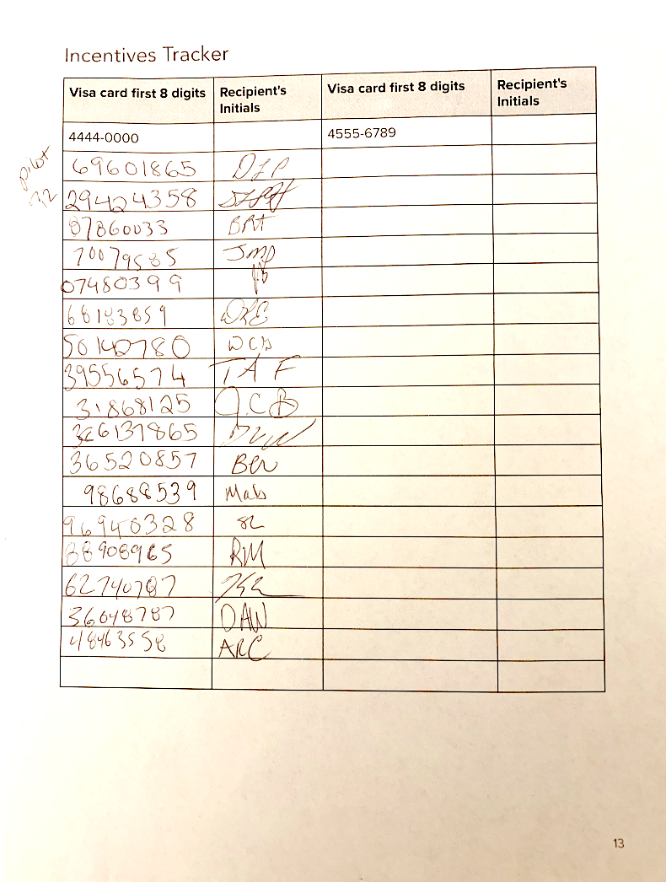

## Appendix: interview question graveyard

Researcher: be ready with post-it notes

* How did you learn about the Pittsburgh VA medical center?
* Other than healthcare benefits, do you use any other benefits from the VA?
* We 100% respect your privacy, so if you're here for an appointment, please do not feel like you need to tell us why. You can refer to it as "the appointment" or "my appointment". We'd like to ask that you don't divulge your personal medical information during the interview.
* [If needed] Will you be using any benefits provided by the VA **today**? Such as healthcare benefits or any others?
* So now, let's walk through your story of how you prepared for today. How did you plan for your visit today?
  + When did you begin planning your visit today?
  + [if needed] Is there anything that you needed to do to prepare for today? Like any forms, medical tests, or records?
  + Researcher: write the participant's steps on post-it notes (1 per step) and place them on your clipboard
* Researcher: share your clipboard with the described journey to the participant
  + Do these steps look right?
  + Would you use a post-it note to list any steps we didn't cover? Feel free to edit any that I may have gotten wrong.
  + [ask Background question 3 here if needed]
* [if needed] So, we just talked about how you're using [benefit] today. How did you learn about these benefits?
  + When did you sign up for them?
  + How did you sign up for them?
    - Do/have you apply(ied) for VA benefits or services online before?
* What types of benefits do you wish the VA would offer?
  + How would you go about finding out whether those wished-for [use the words the participant used earlier] benefits are offered?
  + [Researcher: don't share until after the visit]. Did you learn of any new benefits during this visit?
* May I text or email you with follow-up questions, or if we'd like to speak with you further in another interview? If yes, may I get your mobile number? If no: understood, thank you.

Revised Day 1: